Website deliverable

This document will contain all the information, texts and materials regarding the studies and creation of the website creation project.

Table of Contents

Personas 2

Jennifer 2

Mike 3

Survey questions 4

Survey Explanation 4

Survey Analysis 11

Survey results analysis 11

Interview Transcripts 20

Other Interview material 21

# Personas

## Jennifer

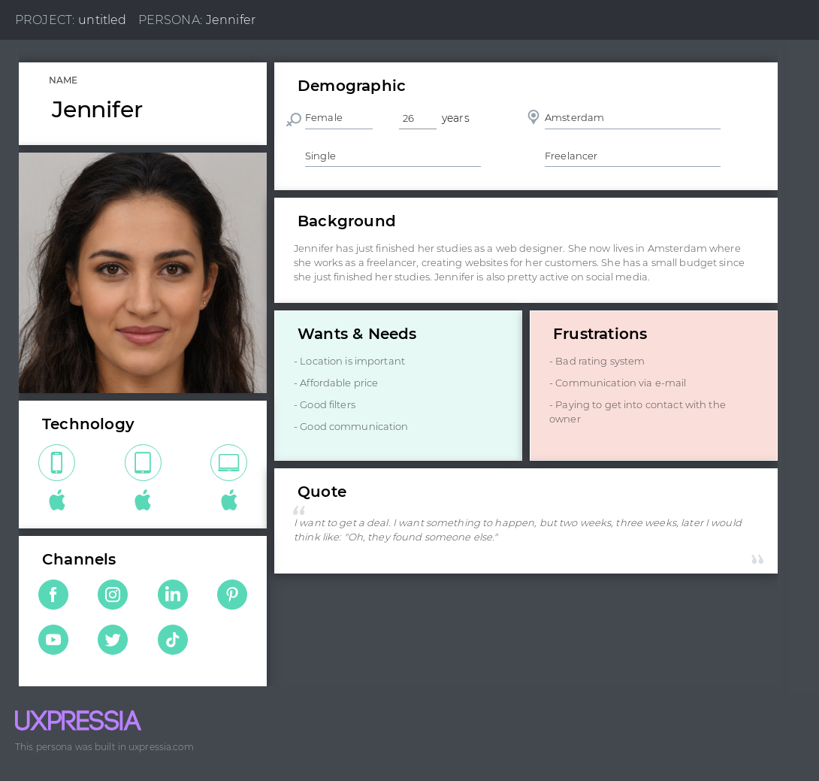

## Mike

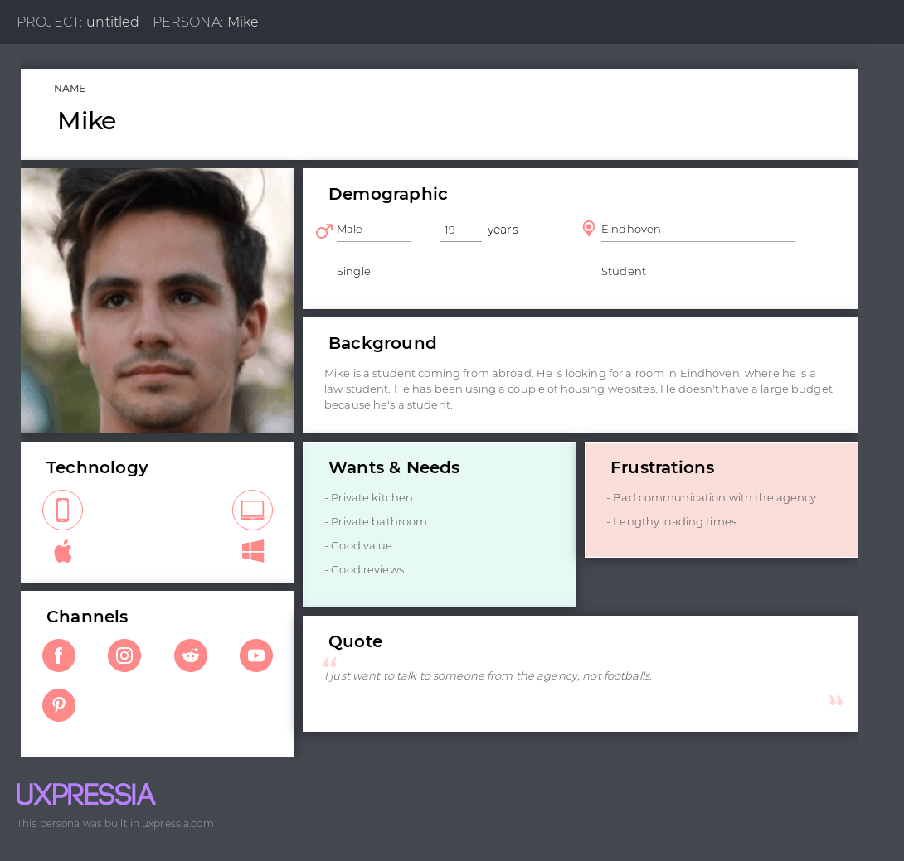

# Survey questions

## Survey Explanation

In our group, we decided to make a housing website as our project. So before we start creating the website, we made a survey. The following survey is aimed towards people that have used a housing website. We want to see their opinions about those websites – what did they like, what did they dislike, what feature helped them throughout this journey of finding the perfect property.

Question 1.

Starting off with the first question from our survey – “In which age group do you belong?”. With this question we can determine whether the person is a student, a worker, or someone who is looking for property for his/her family. People up to 25 years old are usually students looking for accommodation, while attending university. People older than 26 years are most likely to look for a property for their family or they are looking for a place to stay while they are working.

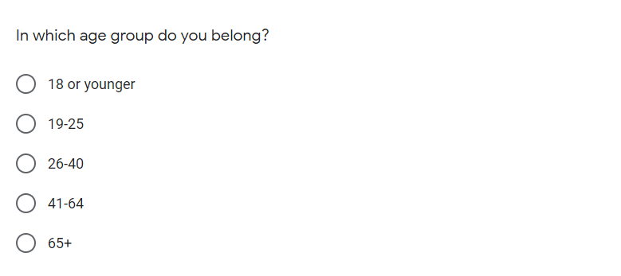

Question 2.

With this question we want to determine whether the person has used a housing website before. That way we will know how many people have looked for a property themselves, or they have made other people look for them.

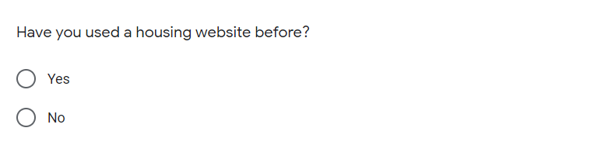

Question 3.

With this question we want to see which website people use the most. That way we can check the most used ones and check if there are any flaws, interesting features, etc. In that website, which we can implement in our own.

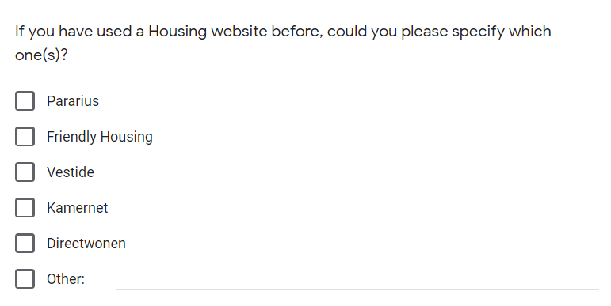

Question 4.

With this question we can see how much time people have spent, using the accommodation websites.

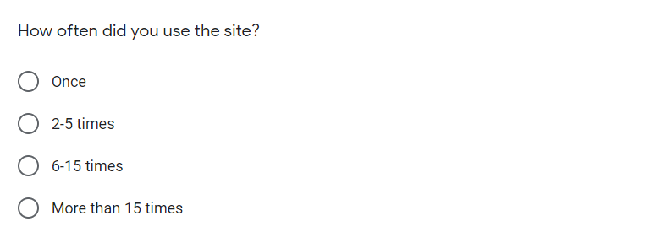

Question 5.

With this question we want to determine whether the user uses desktop, tablet, mobile or other device to access the website. We use this question to see the 2 most used devices. So if the second most used one is mobile or tablet, we will make a port of the website for mobile devices or tablets.

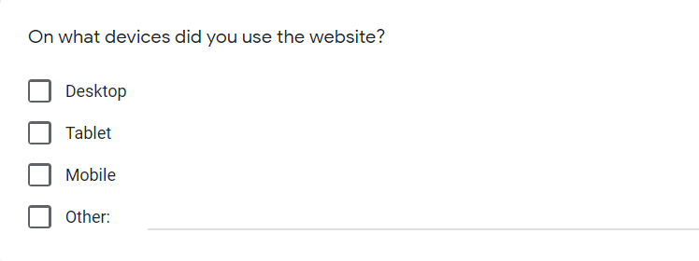

Question 6.

With this question we want to see the two most used languages, so we can add it as a feature for our website. The page will originally be created in English, and in future we can add Dutch or German.

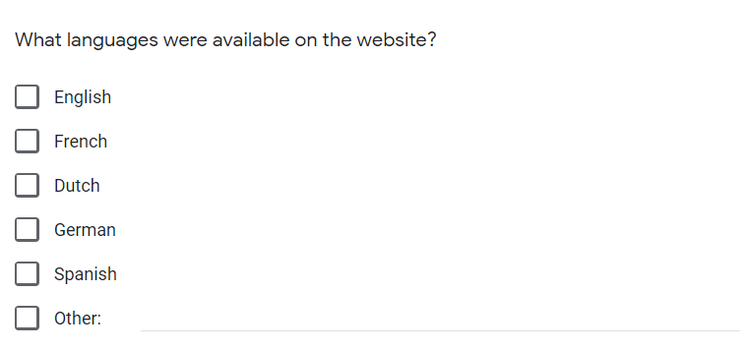

Question 7.

With this question we would like to know If any person has used a feature that made their work easier. A feature that they enjoyed. So we could work on this feature and improve it and later add it to our website.

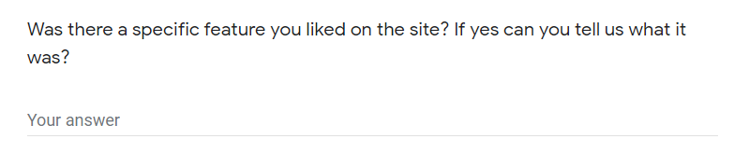

Question 8, 9.

The following two questions are very important part of our research. With them we will be able to determine whether we should add subscription to our website or not. Many websites required subscriptions in order to use them and many times these subscriptions were useless. We could add subscriptions for other features but not for generally using the website.

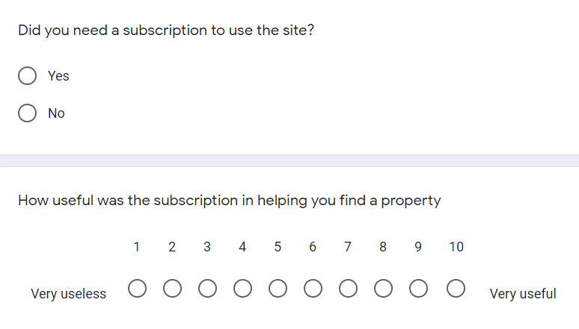

Question 10.

With the following question we can determine what type the user is. A student looking for studio or room, or a family looking for a flat or a house. That way we can divide our listings for easier access to users of the website.

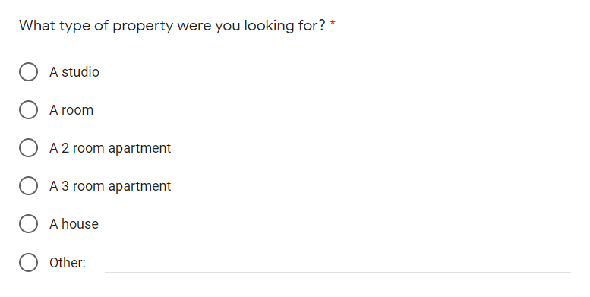

Question 11.

With the following question we want to determine which features are the most important for people when looking for housing. That way we can later add the options as filters for our website. The answers we have here are taken from the 3 interviews we did for the survey. (see “transcript-interview-for-survey-Viktor.docx”, “transcript-interview-for-survey-Yavor.docx”, “transcript-interview-for-survey-Anne.docx”)

Question 12.

With that question our team can determine on which price point of estates we should focus.

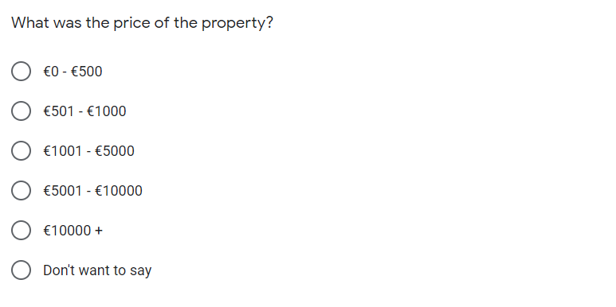

Question 13.

Many people get scammed with fake pictures/photos of the listed estates. We want to see how many of our surveyed people have experienced this scam. We want to implement 360-degree photos in future in our website.

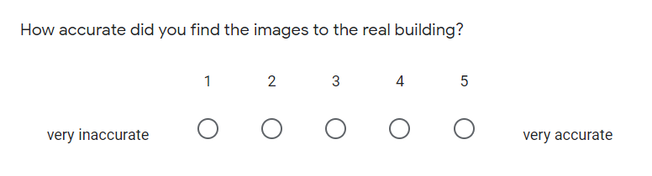

Question 14.

Many housing agencies take quite a lot of time to respond when sent an email/question about a certain property. We want to see from our survey if this is true and if so, usually how many days does it take for people to get response. We would like to eliminate that drawback in our website.

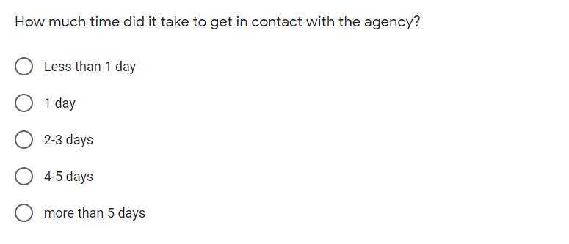

Question 15.

Our last question is a follow-up to the previous one. Wanting to have a more clear view of the process of contacting the housing agencies.

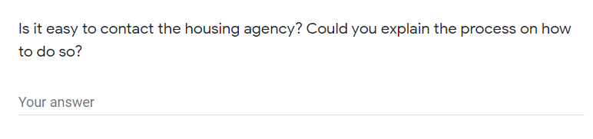

# Survey Analysis

## Survey results analysis

In this document results from the online google forms survey are going to be analyzed and conclusions will be drawn from them. The survey consisted of 15 questions about housing websites and it was conducted before one week. The survey got 14 responses ranging from students looking for rooms where to stay to families looking for a house to live in. The results we collected were very interesting and will help us quite a bit throughout the creation of the housing website.

Question 1:

From this question we have determined that most of the users of the housing websites are people aged between 19-25 years old. That way we don’t need to oversimplify our website’s layout and cut from extra features. (because the less features a website offers, the harder it is to use)

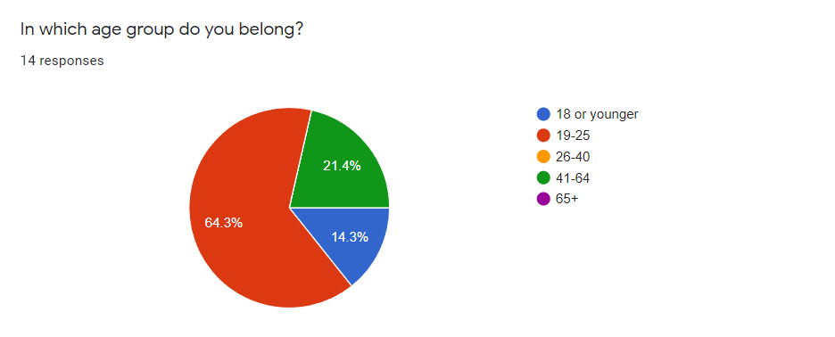

Question 2:

Our second question wanted to see how many of the Ethernet users have used a housing website. We conducted that more than 80% of people have used one. This will make our work easier because we won’t have to concentrate on creating an exactly different website as compared to the others. What will we do is give our website a twist in the layout and make it somehow stand out from he others (in a positive way).

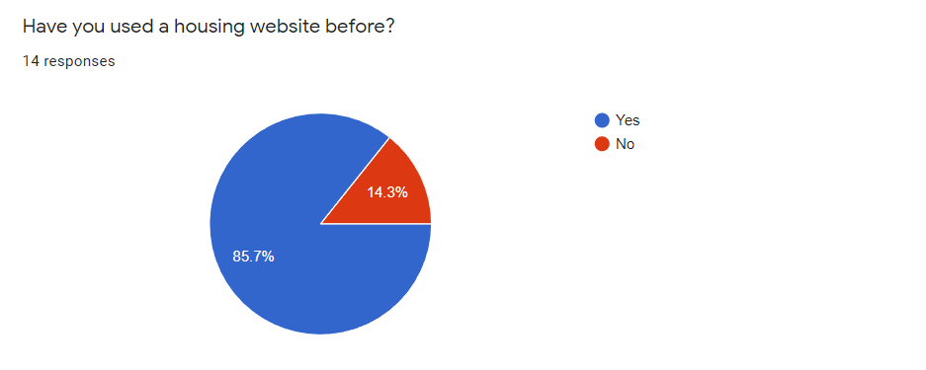

Question 3:

With the following uestion we wanted to see which websites were used the most when It comes to housing listings. The survey gave us the following answers – the most used websites are Pararius, Friendly housing and Kamernet. That gives us very important information. That way before we create our website, we can check those ones and see any flaws, bugs and minuses which we can eliminate and implement in our own. We can also see the similarities between them and that way we can think of a way to make our website distinguish more in terms of layout compared to them.

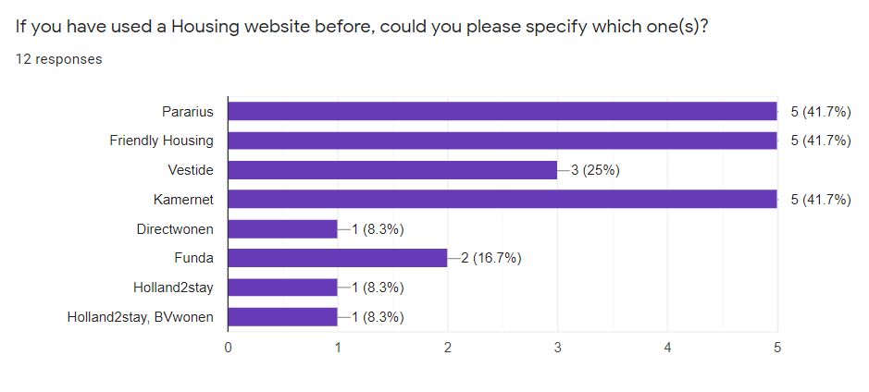

Question 4:

The following question gives us the result of how many times people use a housing website. Our If they use it less than 5 times – either the website sucks or it is too hard to use, or there isn’t enough info on it. If the website is used more than 5 times, therefore it works as intended. That’s what our team is aiming for.

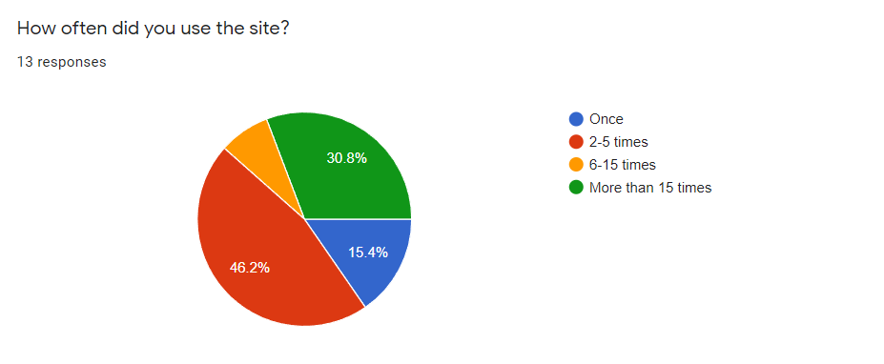

Question 5:

Even if the following question looks useless to some people, it gives our team very important answer – To make the website phone compatible. Even though people mostly use PC, quite a few of them also use their phone. The whole coding process won’t be any harder, because it just involves a few lines of code. That way it will be more user friendly. People won’t have to deal with a desktop sized website on their mobiles and make it harder to use. That way we can attract more people to using it and more easily gain popularity.

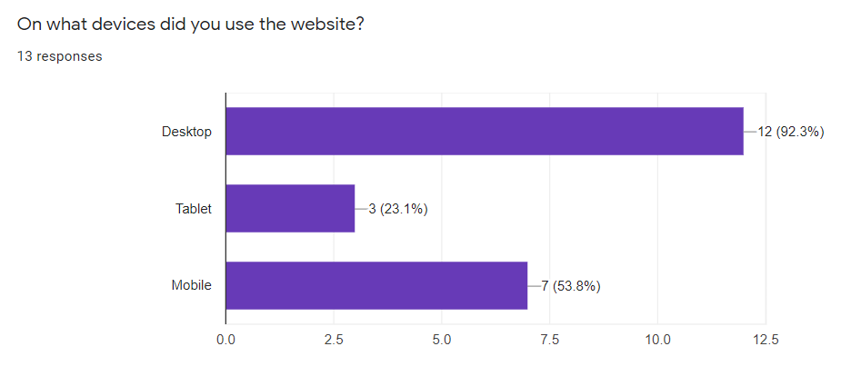

Question 6:

The following question of the survey shows us the most commonly available languages in the housing websites. That way we can see that Dutch and English are the most commonly used ones. This means our website will have English and Dutch language translation built in and/or offer language translation option of some sort.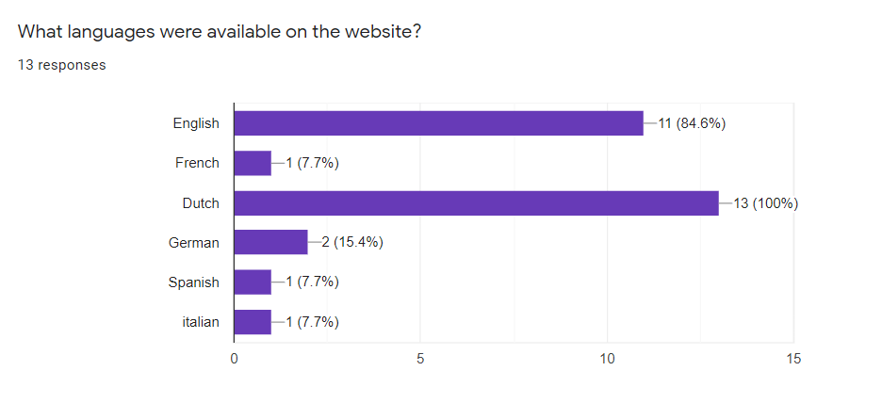

Question 7:

With the following question from our conducted survey we learned about many different useful features. In future we can implement some of them in our website in order to make the user experience better and easier to use. After all our website should be as advanced, outstanding and user-friendly as possible.

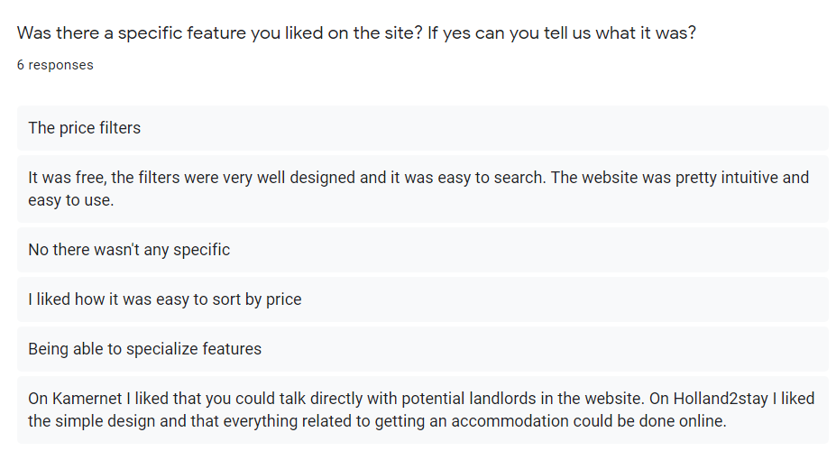

Question 8:

During the creation of our survey, out team determined that many of the housing websites require subscription in order to use them. Most of them were useless and some of them were quite expensive. That’s why we added that question to our survey. That way we concluded that people would rather use a website that doesn’t require subscription, and such website will be ours.

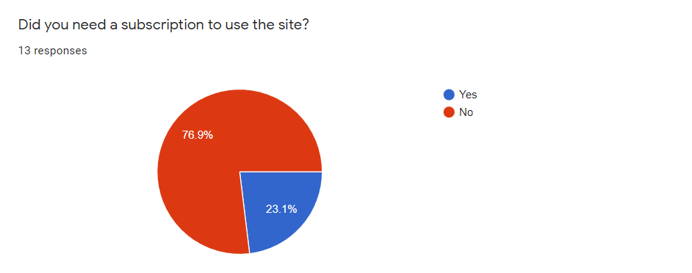

Question 9:

This is a follow up question to the previous one. It shows that subscriptions for the website have little to no use. That’s another reason not to include a subscription.

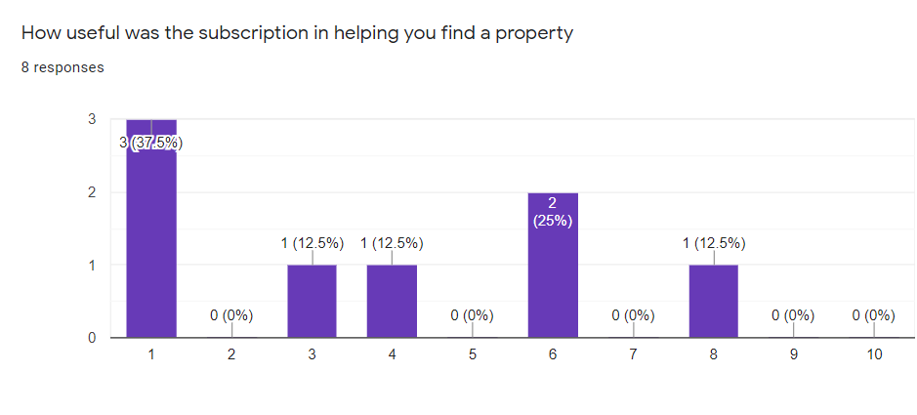

Question 10:

This question shows us what is the most searched type of property. Rooms and houses are the answer. Those two types of estate will have more detailed filters and will require extra attention from our team while developing the listings.

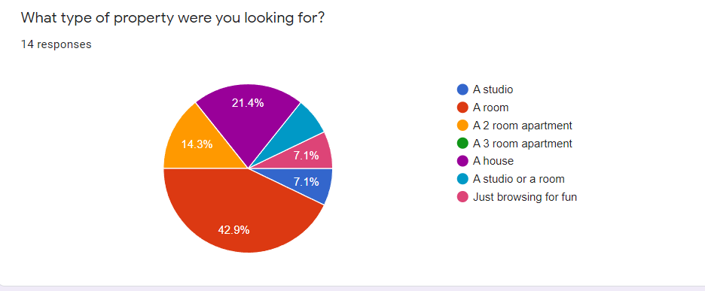

Question 11:

With this question we want to see what feature of the property was most important to users. We concluded that there are 3 very important features: properly maintained property, private bathroom, and good reviews are the most important ones. Later in our website we will add them as an option to the filters. We will also add others, but those will be the main ones.

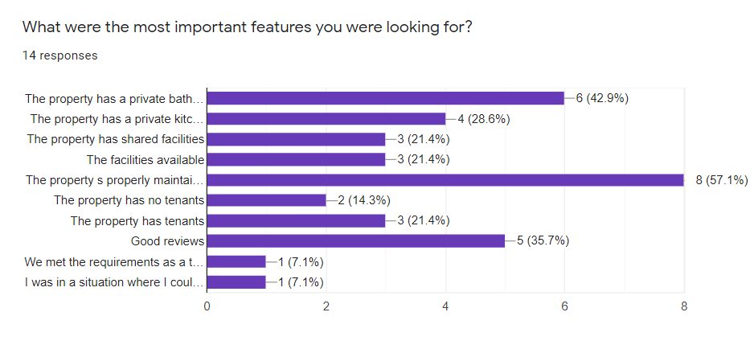

Question 12:

Another filter we will add is proper price range with the option to add your own price range. With that question we want to see the most commonly filtered prices for housings. We see that people mostly use the 0-500 price tag. So what we will do is make it more detailed. For example we will add filter: up to 250 euros, 250-360 euros and 361-500 euros. And also we will include bigger price tags. Price filters will be different according to the category. Also for houses we will use higher price filters, because there aren’t any houses under 500 euros.

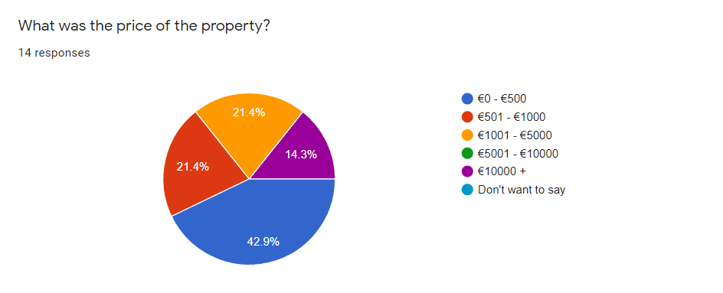

Question 13:

With the following question our team wanted to determine whether the estate pictures were accurate or not. We are also planning to add 360 degree pictures as a virtual tour addition to listings. That way such picture would attract more people not only to the property, but to the website as well, because there isn’t a website that offers 360 pictures of the property.

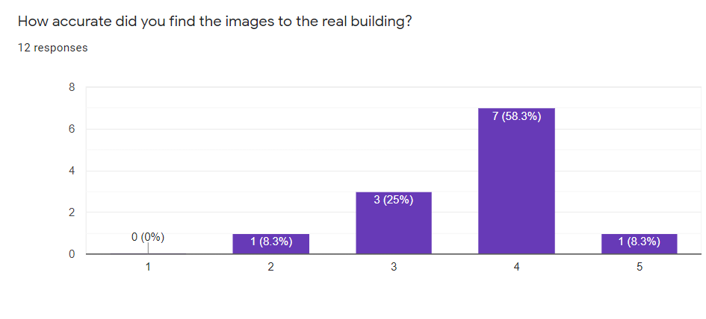

Question 14:

Response time is very important when it comes to communication with estate and housing agencies. Most people got in touch with the agency/landlord within 3 days. This is not bad, however we would like to improve this part. Adding response rate to every landlord, so the person could expect the amount of time they will need for a response. Some websites have such feature and it is working quite well.

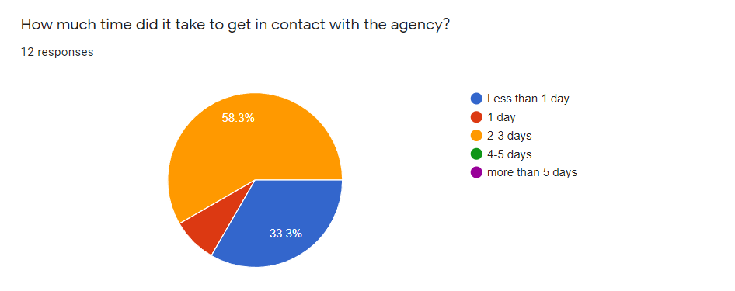

Question 15:

Our last question was a follow up to the previous one. Some websites had a positive feedback, some not. What really matters here is to see the different types of communication and their success rate. This document is later going to be compared to the surveys conducted on video and answers will be more clear. Our website will offer 2-3 ways of contacting either the agency or landlord (we have yet to determine the options). For some agencies the whole procedure was complicated, for others it was easier. We want to find the balance, however we should somehow limit the spam rate.

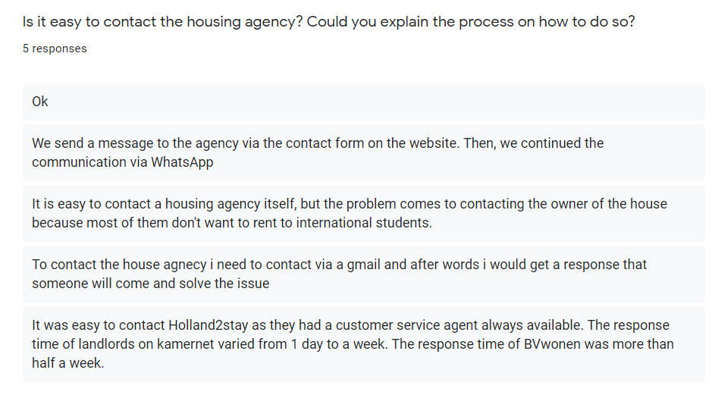

# Interview Transcripts

# Other Interview material